**Car Dealership System**

**Lab – 08: Data Flow Diagram**

**Group Number: 02**

**Group Members:**

|  |  |
| --- | --- |
| Student Id | Student Name |
| 19101069 | Md. Mahbubur Rahman Raad |
| 19101088 | Md. Mehtabul Islam Shafin |
| 19101076 | Sayem Kader Chowdhury |

Date of Submission: 23rd April 2021

**Level – 0 Diagram:**

The Level – 0 Diagram shows the main process which comprises our Car Dealership System.

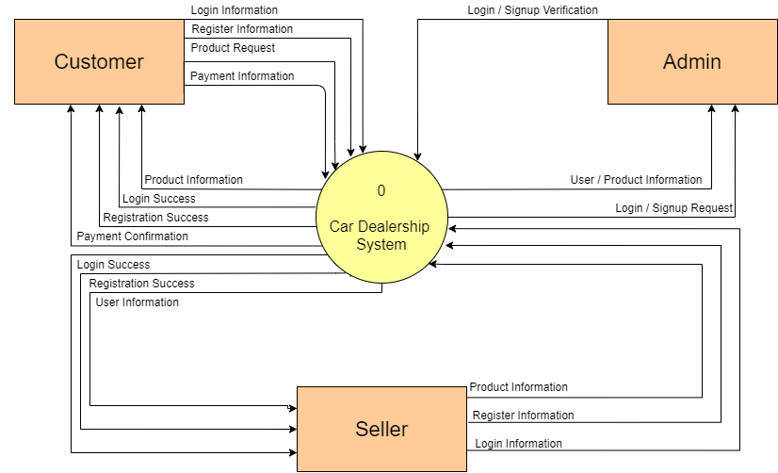

*Figure 1.0: Level – 0 DFD*

**Level – 1 Diagram:**

The Level – 1 Diagram shows all the processes which comprises a single process in our Car Dealership System. We have included four main processes i.e. the Login process, the View Product process, the Interaction process which includes buy, book, upvotes, downvotes, interact with the seller through chat and call, and finally, the payment process.

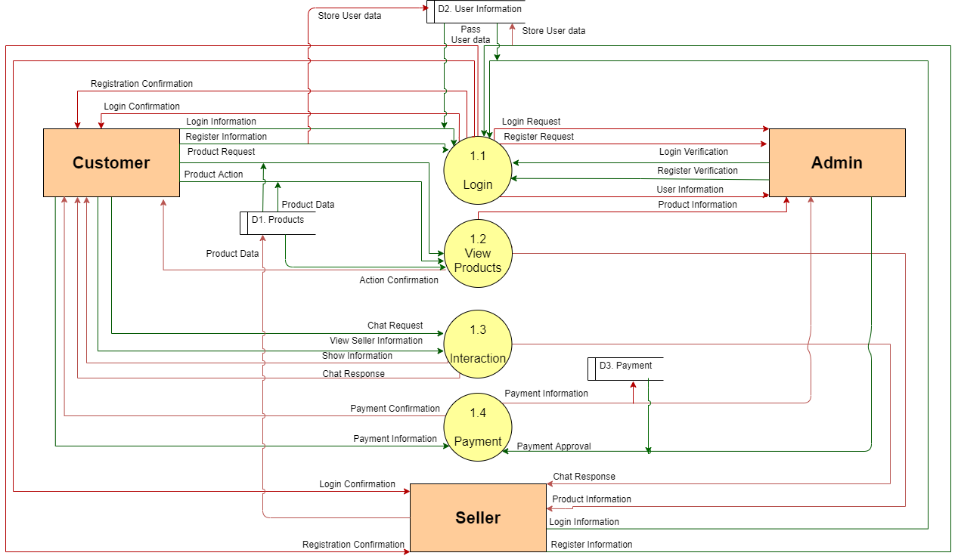

*Figure 1.0: Level – 1 DFD*

Drive Link to the Diagrams: https://drive.google.com/file/d/1pLrsFaHSa4G5A8fB1TFHzv3FfqMWAUX_/view?usp=sharing